WEEK 3 -THEORY
UI Architecture - Theme, Widgets, Screens

 Learning objectives
- Structure Flutter widgets for extendibility and consistency
- Comply with coding conventions
- Create a library of generic widgets aligned with a design system
- Understand the dart concepts of static methods, attributes

How to start?
- Create a GitHub repository for this project
- Get the start code, including the Figma Design System
- Ensure you can run the start project on your computer

How to submit?
- Make sure you follow the COMMIT standards (see below)
- Push the start code into your repository (commit: BLA-000- Start Code)
- Once finished, submit to MS Team:
  - GitHub URL
  - This document

You are not allowed to use AI to submit this work

ACTIVITY 1 – Analyze the model layer

The model layer - so far - is composed of 6 classes:
Ride, Location, Country, DateTime, User, RidePref

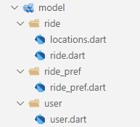

✏️ Draw the UML class diagram representing the relationships between those 6 classes.
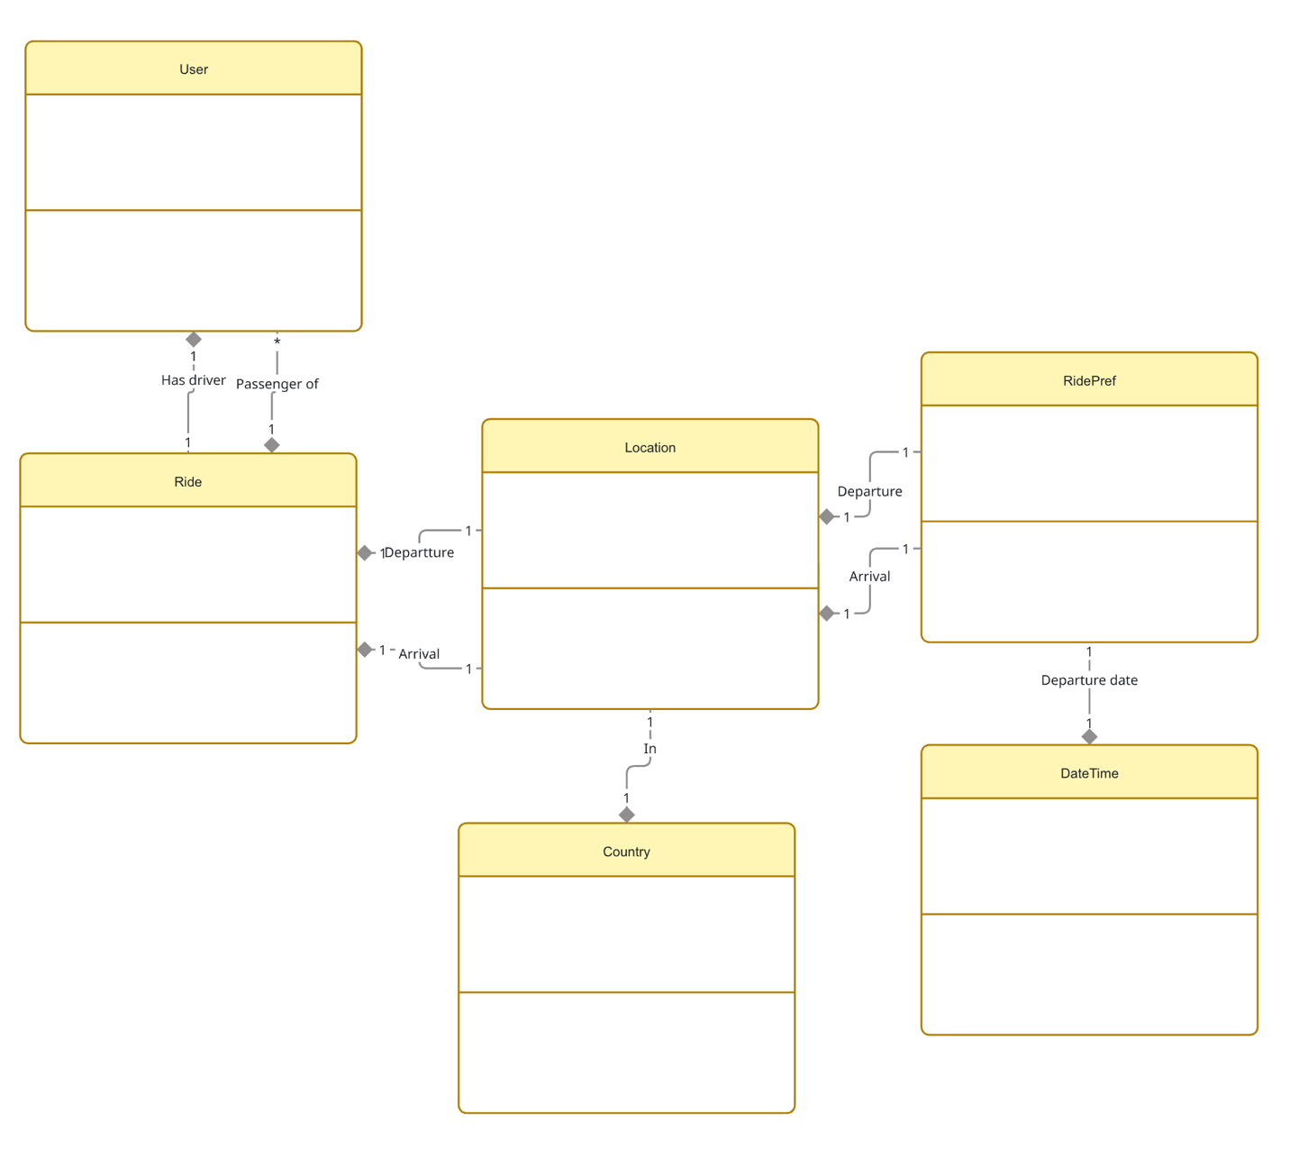
(no attribute, methods, just associations relationships)

✏️ What is the goal of the operator== and the hashCode method in Location class?
the custom == says two Location objects are “the same place” when both name and country match, even if they are different instances in memory

hashCode is made from name.hashCode ^ country.hashCode

together, they let collections like Set<Location> or Map<Location, ...> work by value

ACTIVITY 2 – Understand the difference between instance and static access

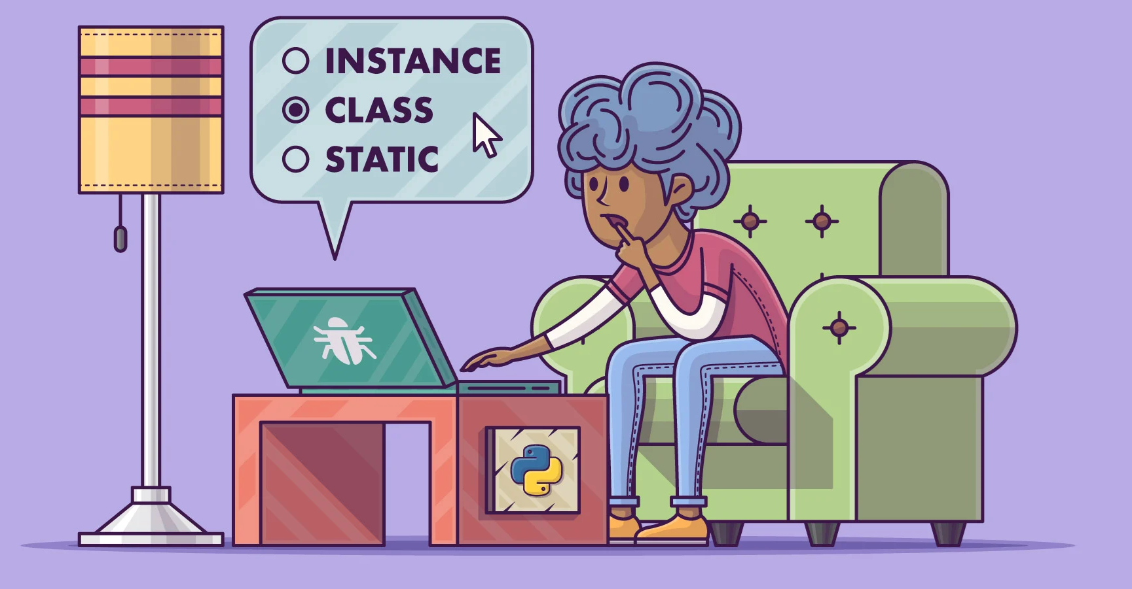
Answer the quiz in class

ACTIVITY 3 – Understand and analyze a first view: Ride Preferences screen

Let’s build step by step a Ride Preferences screen, showing only the past entered ride preferences.

✏️ Understand the methodology, steps, and coding standards to implement this view

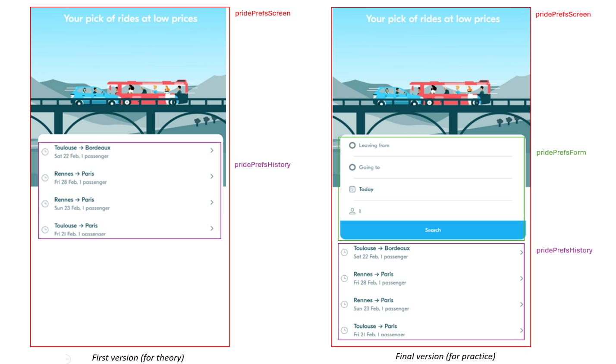

✏️Explain how the font (Eesti) is loaded from the assets and is applied to all widgets.
- flutter looks at pubspec.yaml first
there, under flutter/fonts, the family Eesti is declared and all the .otf files are listed
- when the ap starts, main.dart builds MaterialApp with theme: blaTheme
- in blaTheme (in theme.dart), fontFamily: 'Eesti' is set for the whole theme
- because of that, every Text widget that does not override style.fontFamily will show with the Eesti font automatically

✏️ Analyze how the history tile interacts with the App theme.
History Tile | BlaTextStyle | BlaColor
title | uses Text(title, style:BlaTextStyles.body)  so it takes the “body” text style defined once in BlaTextStyles, keeping size and weight the same everywhere | the history icon and the arrow use BlaColors.iconLight
subtile | uses BlaTextStyles.label.copyWith(color: BlaColors.textLight)  that means it starts from the shared label style and only change the color | subtitle text color is BlaColors.textLight  so the tile never hard‑codes colors or fonts, it only reuses the shared theme classes,

✏️Explain how the date is converted into a readable label
RidePrefsTile calls DateTimeUtils.formatDateTime(ridePref.departureDate) to build the subtitle

inside DateTimeUtils.formatDateTime:
- it removes the time part and compares only the date to “today”
- if it is today → returns "Today"
- if it is yesterday → returns "Yesterday"
- if it is tomorrow → returns "Tomorrow"
- else it uses DateFormat('E d MMM') to make a short string like Wed 12 Feb

✏️ Analyze the Ride Preferences screen and complete the table.
Widget | Screen / Screen Widget /App Widget | Parameters | Callbacks
RidePrefScreen | Screen | none | None to parent, but onRidePrefSelected exists privately
BlaBackground | Screen widget | blablaHomeImagePath | none
RidePrefHistoryTile | App widget | ridePref, onPressed? | onPressed

✏️ At home, try to reproduce it by yourself (with the correction for help)

